**Payment Workflow API**

1)Open Navision Development environment.

Click File and Import.

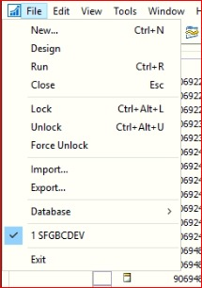

2) Browse the location of fob and import the files.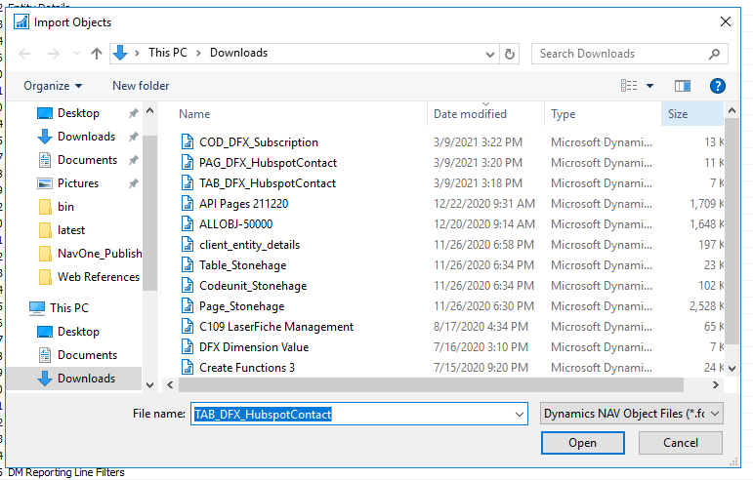

3)Object created successfully

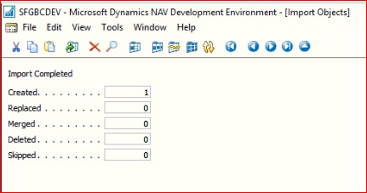

**Total Objects – 1**

**CodeUnit:**

50000 – API Functions.

4)Schema Sync. has to be done for all tables.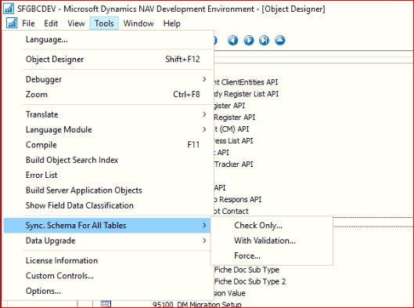

5)Click ok to proceed on the process of sync.

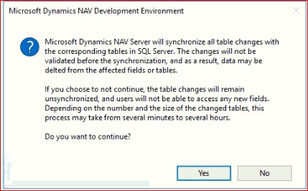

6)Once sync. is done(100%) close the window.

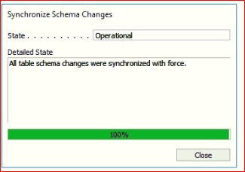

7)Open Nav windows client and search web service.

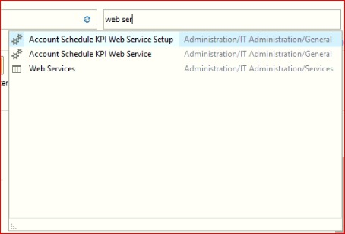

8)Click New to create web service for the API Function Codeunit [ If its already exists then SKIP].

